# 

# 

# Amazon Travel Club

Table of Contents

Amazon Travel Club 1

INTRODUCTION: 3

DATABASE TABLES 4

REA DIAGRAM 8

8

ER DIAGRAM: 9

CONCLUSION: 10

REFERENCES: 10

Figure 1customer table 4

Figure 2Inventory table 5

Figure 3Invoice table 5

Figure 4Order List 6

Figure 5Purchase order 6

Figure 6Shipping Department 6

Figure 7Supplier 7

Figure 8Vendor Table 7

Figure 9Expenditure 8

Figure 10Revenue 8

Figure 11ER Diagram 9

# INTRODUCTION:

The given brief is based on the online order portal named amazon travel club. The work of this Amazon travel club is to take orders from the customer over online or by email and telephone. As given in the brief we have created an appropriate table for our database. We have created customer table as well as we have created an inventory table, invoice table, order list table, purchase list table, shipping department, supplier, and vendor. According to brief if some order will be delayed for delivery than there should be 30% charge will be taken. The above database is created according to the brief given.

## DATABASE TABLES

According to the given brief, we have created some of the tables which are very needed to fulfill the requirements of the given brief. Tables are given below:

1. Customer
2. Inventory
3. Invoices
4. Order List
5. Purchase Orders
6. Shipping Department
7. Suppliers
8. Vendor

**CUSTOMER:** In this table, we have declared field related to the name given. This table is used to take the order from the customer. In this table, we have declared some fields like CustomerID, CustomerName, CustomerNumber and etc. For storing details of every customer we have created customer table in our database. This table is related to other tables also to create relationship databases between the tables.

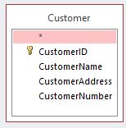

Figure 1customer table

**INVENTORY:** This table inventory is used to maintain the limited number of list of our database. We have created this table to show some limited amount of information from the database. In this table, we have created some fields like InventoryID, InvoiceID, Order_Name, CustomerName. This table is related to other tables also to create relationship databases between the tables.

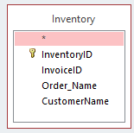

Figure 2Inventory table

**INVOICE:** This table shows the order statement of the order. If the order is delivered then there should generate a message that order is delivered. And if the order is not delivered then should generate a message that order in on the way. This table is related with another table also to create relationship database between the tables(Brodersen, Rothwein, Malden, M.S, Chen, M.J. and Annadata 2004).

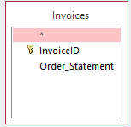

Figure 3Invoice table

**ORDER LIST:** This table is created to store the order information of the particular customer. This table consists of some fields like Order_ID, Order_Name, Rate, Quantity, CustomerID, Orderd_Date, VenderID, supplied. To make a relational database we have linked other databases fields to make a relationship. This is the main order of this database. And created according to the brief.

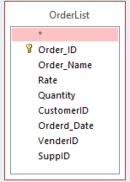

Figure 4Order List

**PURCHASE ORDER:** This table is used to store the order purchase details for our Amazon database. Whenever any customer will order something the purchase data detail of that particular order will save on this table. We have created some fields like PurchaseID, VenderID, CustomerID, Order_ID. These tables are related to another table also to make a relational database.

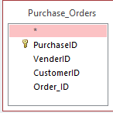

Figure 5Purchase order

**SHIPPING DEPARTMENT**: This department is very important in any online order services portal. The main task of this department is to deliver the product at a minimum time and on correct address. We have created some fields like ShipmentID, Order_ID, Shipping_Address, Ordered_Date and etc. This table is related to another table also to make relation databases.

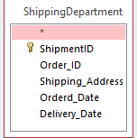

Figure 6Shipping Department

**SUPPLIERS:** In this table, we have created some fields that will fulfill the need of the supplier to reach the product in minimal time. Whenever a customer will order something the task of the supplier will start. He or she will check the stock that the order is available in the stock or not. We have created some fields like SuppID, SupplierName, CompanyAddress, City, Phone and etc.

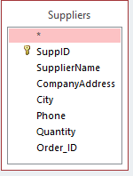

Figure 7Supplier

**VENDOR:** Vendor is a supply chain in this business. The vendor is an enterprise that contributes to goods and services. In our database, we have defined four types of the vendor as Electronics, Dress, Shoes, Beauty Product(Fulton, M.S., International Business Machines Corp, 2013).

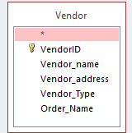

Figure 8Vendor Table

### REA DIAGRAM

### 

Figure Expenditure

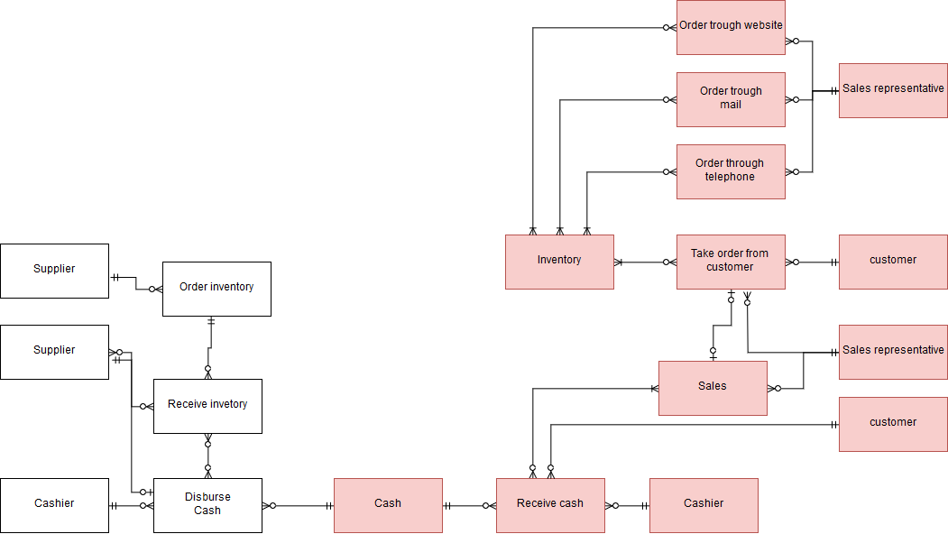

Figure Revenue

### ER DIAGRAM:

An entity-relationship diagram is used to describe the functionality of our database. This is the first most step of the database management process. With the help of ER diagrams, we can make the database very easily. This relationship diagram shows the connectivity between the tables which we have created in our database. All tables of our database are linked in this relationship diagram with each other.

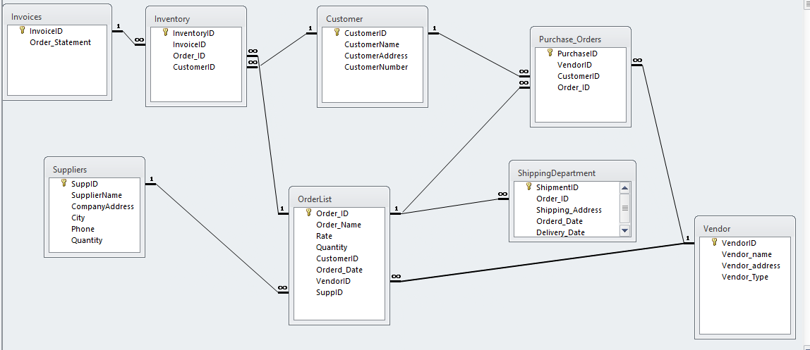

Figure ER Diagram

# CONCLUSION:

According to the given brief, we have created the database and database table. All database table are related to each other. This relationship is very important to create a database. Because in database management every table of the database is related to each other. Each and every field of the table is linked with another table also. So to link that databases from the different tables the relationship database are very important in database management. The given solution is appropriate as given brief.

# REFERENCES:

Brodersen, K., Rothwein, T.M., Malden, M.S., Chen, M.J. and Annadata, A., Siebel Systems Inc, 2004. *Database access method and system for user role defined access*. U.S. Patent 6,732,100.

Fulton, M.S., International Business Machines Corp, 2013. *Method, system, and program product for organizing a database*. U.S. Patent 8,495,102.